CERAMIC COATING
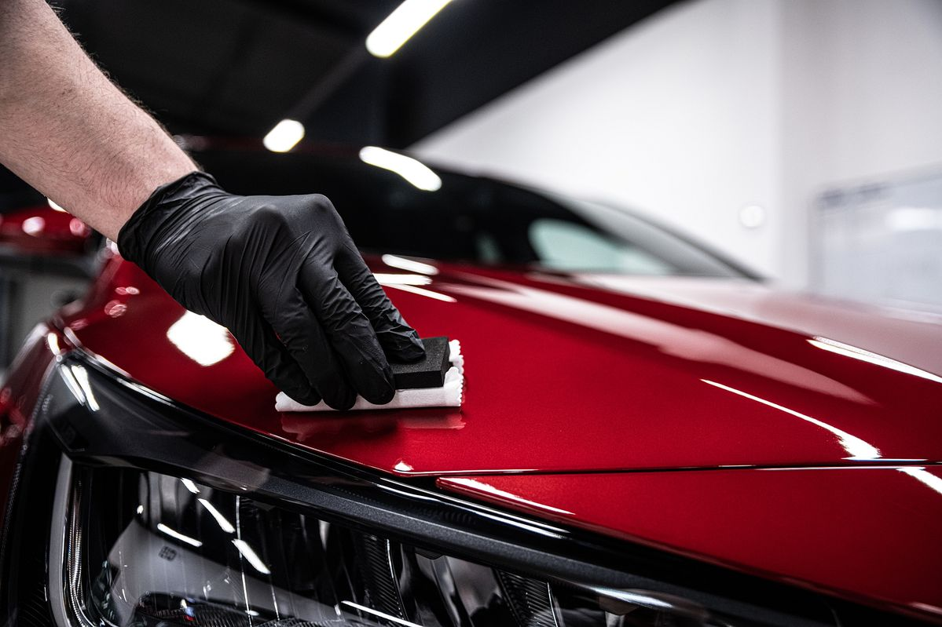
Ceramic coating is a premium car care solution that protects paint, enhances shine, and reduces maintenance. It creates a long-lasting shield against dirt, UV rays, and scratches, making vehicles look newer for longer
* Superior Protection - Shields against UV rays, oxidation, acid rain, and contaminants.
* Scratch Resistance - Reduces swirl marks and minor scratches.
* Hydrophobic Effect - Water beads and rolls off, keeping the car cleaner longer.
* Gloss & Shine - Enhances paint depth and mirror-like finish.
* Ease of Cleaning - Dirt, mud, and grime don’t stick easily.
* Long-Term Value - Preserves resale value by maintaining paint quality.

Graphene coating
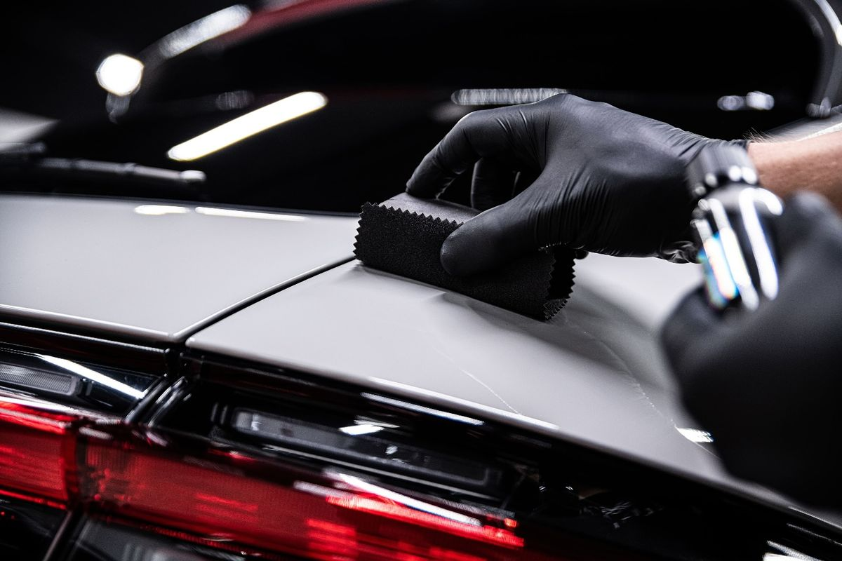
Graphene coating is the latest advancement in car paint protection, offering stronger durability, cooler surfaces, and better resistance to water spots compared to traditional ceramic coatings.

* Superior Durability - Stronger than ceramic, resists scratches and chemicals
* Heat Dissipation - Keeps car surfaces cooler, useful in hot climates like Tamil Nadu
* Hydrophobic Effect - Water beads off quickly, reducing water spots
* Gloss & Depth - Provides a deep, mirror-like shine
* Anti-Static Properties - Repels dust more effectively than ceramic
* Long-Term Value - Protects paint, enhances resale value

Paint Production Film – PPF
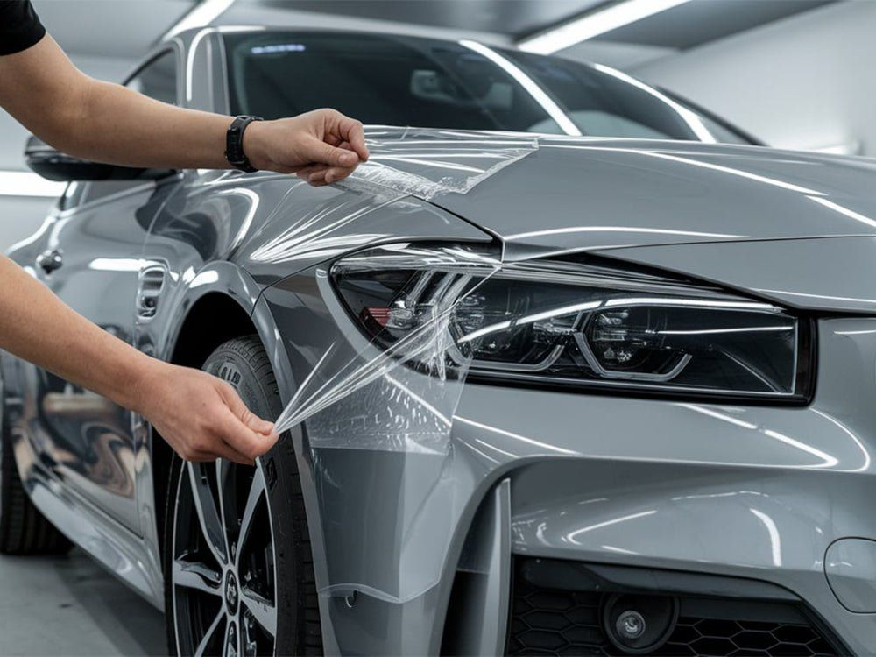
Paint Protection Film (PPF) — the transparent polyurethane film applied over car paint to protect it.
* Scratch & Chip Resistance - Protects against stone chips, minor scratches, and abrasions
* UV Protection - Prevents paint fading and oxidation
* Self-Healing - Minor scratches disappear with heat/sunlight
* Gloss or Matte Finish - Enhances look while keeping paint fresh
* Ease of Cleaning - Repels dirt, water, and stains
* Resale Value - Maintains factory paint, boosting resale price

